Supplementary Materials

Study S1: Do Strong Norms Reduce Temptation?
We began this project with a pilot test of our theory that behaviors such as eating or checking social media are less likely to come to mind and seem less tempting in situations in which they are more strongly proscribed by social norms. Participants responded to five pairs of situations in a within-subjects design (10 situations total). Each pair concerned a specific, potentially tempting behavior and experimentally varied the strength of a social norm discouraging that behavior. For example, participants were asked to imagine feeling sleepy while in a meeting in a large conference room (stronger norm) or while watching a movie with friends (weaker norm). We predicted that people would report being less likely to think of a relevant behavior (e.g., “take a nap”), to be less tempted by the behavior, and to be less likely to carry out the behavior if it violated a strong norm than if it violated a weaker norm.
Method
For Studies S1-S4 data will be made publicly available on OSF (https://osf.io/qr7ws). All procedures were approved by the researchers’ Institutional Review Board. In each study, data were analyzed only after data collection was completed.
Participants. Two-hundred and two adult US residents (M_{age}=35.17, SD=10.34, 57% male) were recruited online using Amazon’s Mechanical Turk. Due to an oversight, we did not collect race/ethnicity data in this or any of the following studies. We planned to run a minimum of 200 participants and determined this sample size prior to data collection. We did not have a clear basis for estimating an effect size so we chose to run 200 participants as it is large enough to detect even small effects (n=200 provides over 80% power to detect an effect as small as d=0.20).
Procedure. Participants responded to ten scenarios, which examined temptations to take food, to check social media, to express anger, and to take a nap (see Table S1). The five stronger-norm scenarios were presented in one block and the five weaker-norm scenarios in another block. Which block came first and the order of scenarios within blocks was randomized.
For each scenario, participants rated: (1) how likely they would be to think of doing the target behavior (1=I would definitely not think of doing this, 7=I would definitely think of doing this); (2) how tempting it would be to do the target behavior if they thought of it (1=not at all tempting, 7=extremely tempting); (3) how difficult it would be to resist the behavior (1=not at all difficult to resist, 7=extremely difficult to resist); (4) how likely they would be to do the behavior (1=not at all likely, 7=extremely likely); and (5), as a manipulation check, how inappropriate they thought it would be to do the behavior (1=not at all inappropriate, 7=extremely inappropriate).

Table S1. Scenarios from Study S1.
Scenario Name and Self-Regulation Domain | Stronger Norm | Weaker Norm | Behavior
“Take a Nap”; Sleeping | You have been in a meeting in a large conference room for a long time. You begin to feel sleepy. | You are hanging out with friends, watching a long movie. You begin to feel sleepy. | Lay your head down and take a nap
“Eat Off Other Person’s Plate”; Eating | You are very hungry, and happen to be sitting next to a stranger who has a plate of food that looks and smells delicious. | You are very hungry, and happen to be sitting next to a close friend or family member who has a plate of food that looks and smells delicious. | Reach over and take a bite of their food
“Yell About Spilled Drink”; Emotion regulation | You are walking in the park carrying a drink. A toddler bumps into you and causes you to spill your drink all over yourself. | You are walking in the park carrying a drink. A stranger bumps into you and causes you to spill your drink all over yourself. | Yell at him for not paying attention
“Check Phone/Email”; Media use | You are attending a lecture given by a veteran who lost a leg fighting terrorism. The lecture is about foreign affairs. You begin to feel bored. | You are attending a lecture given by a local university professor who authored a book about terrorism. The lecture is about foreign affairs. You begin to feel bored. | Open up your laptop or phone and check email, Facebook, or Twitter
“Take Second Serving”; Eating | Your friend hosts a formal dinner party where five courses will be served. The host brings the food out from the kitchen to a side table. She sets out the first course on carefully arranged plates and serves it to each guest. The first two courses are delicious, but you find the third course especially delicious. You finish your serving quickly. | Your friend hosts a casual dinner party where five dishes will be served. The host brings the food out from the kitchen to a side table. She invites each guest to help themselves. You find two dishes delicious, but a third dish especially delicious. You finish your helping quickly. | Go to the side table and serve yourself more of the third [course/dish]

Results
Validating our manipulation, participants rated the behaviors as more inappropriate in the stronger-norm scenarios (M=5.70, SD=0.94) than in the weaker-norm scenarios (M=4.01, SD=1.05), paired t(201)=20.03, p<0.001, d=1.69.
Critically, participants reported that they would be less likely to think of doing the behaviors in the stronger-norm scenarios (M=2.88, SD=1.31) than in the weaker-norm scenarios (M=4.39, SD=1.38, paired t(201)=17.27, p<0.001, d=1.12); that the behaviors would be less tempting (M=3.52, SD=1.31, M=4.88, SD=1.28, respectively; paired t(201)=16.28, p<0.001, d=1.05), and easier to resist, (M=2.87, SD=1.24, M=4.05, SD=1.53, respectively; paired t(200)=13.47, p<0.001, d=0.83); and that they would be less likely to do them, (M=2.15, SD=1.00, M=3.64, SD=1.20, respectively; paired t(201)=18.71, p<0.001, d=1.33). See Figure S1. The effects were statistically large, and robust across all five pairs of scenarios.

Figure S1. The degree to which participants reported they would “think of” doing five behaviors, and would find them tempting, difficult to resist, and be likely to do them as a function of the strength of the norm discouraging the behavior in the context (Study S1).
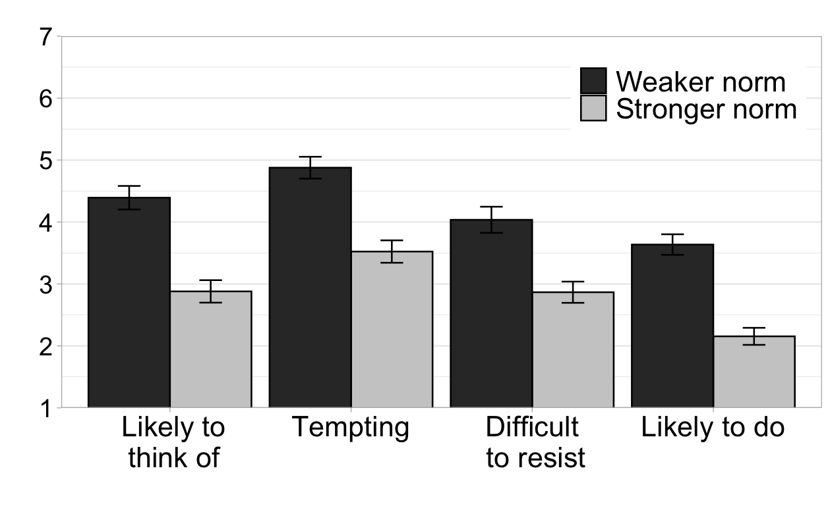Note. The full scale for each outcome is depicted. Error bars indicate bootstrapped 95% CIs (Ns=201-202).

Study S2
Participants. 260 US participants (51.15% male, M_{age}=34.62) were recruited from Amazon Mechanical Turk.
Materials and Procedure. Procedures were the same as those in Study 1 of the main text, except that, after providing ratings of whether they would “think of” (1=Definitely not, 7=Definitely) and “want to” (1=Not at all, 5=Very badly) various behaviors in various situations, the same participants provided ratings of how “appropriate” and “common” those behaviors were in those situations.
Items were the same as those in Study 1, except that the motivational state and associated behavior, “you feel angry/yell and argue,” replaced “your feet hurt/take your shoes off and rest” used in Study 1. The same item-level exclusion criteria were used for items involving smartphones, alcohol, and airplanes (3.6% of responses). We also excluded two participants whose responses to the norm items had zero variance (e.g., straight “7” responses) and two who provided no responses to the norm items.
Results. As in Study 1 in the main text, participants’ ratings of injunctive and descriptive norms were highly correlated (median within-participant r=0.84, IQR=[0.71, 0.92]), and thus averaged to create a single norm composite variable.
We calculated the within-subjects correlations between perceived social norms and the extent to which participants said they would think of and want to do various behaviors. As in Study 1, these correlations were exceptionally strong: for “think of,” median r=0.81, IQR=0.68, 0.90; for “want to,” median r=0.67, IQR=0.48, 0.82).
By-item analyses showed the same pattern as Study 1. Averaging across participants’ responses to each of the 169 items, we again observed strong correlations between the strength of the perceived social norm and whether a behavior would be thought of (r=0.94) and desired (r=0.87) (Figure S2).
Finally, we used linear mixed-effects models to further examine the predictive effect of norms. These models included random intercepts for situation, behavior and subject, as well as by-subject random slopes for the effect of norms. We compared models with and without a fixed effect of norms, and determined the effect of norms to be significant if the fit of the model including this term differed significantly from the fit of the model without this term. Confirming our hypothesis, norms significantly predicted participants’ ratings of whether they would think of (χ²(1)=592.37, p<0.001) and want to do (χ²(1)=413.37, p<0.001) a given behavior in a given setting.

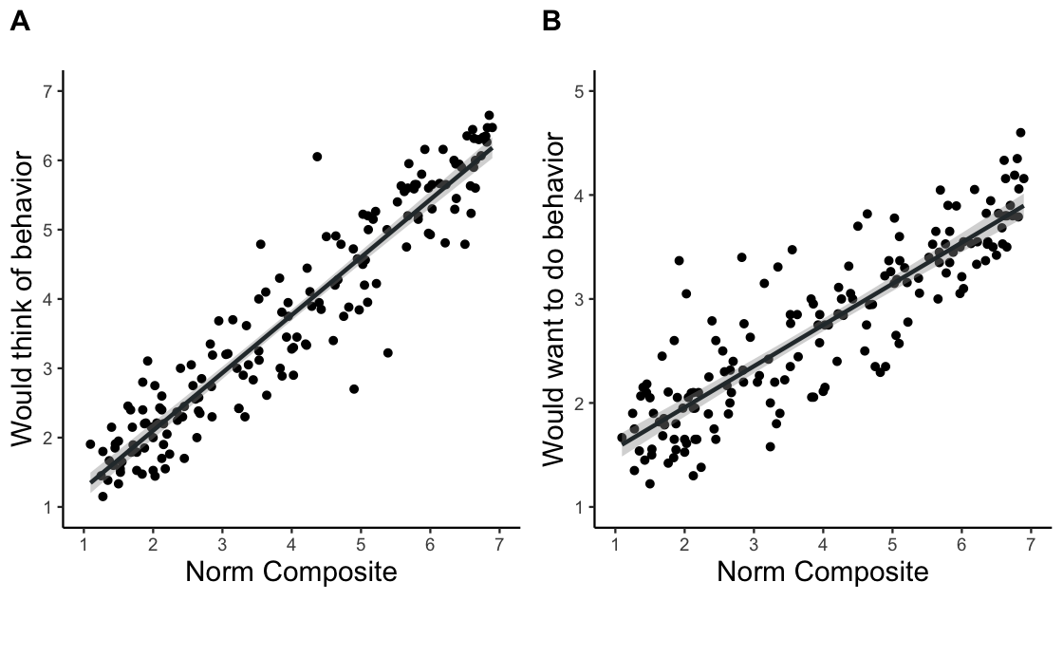
Figure S2. Correspondence between perceptions of social norms and the extent to which behaviors are judged likely to come to mind (Panel A) and to be desired (Panel B) across situations (Study S2, N=260).
Note. Each point represents averaged responses of 18-21 participants to one item (e.g., “take a nap in a library, if you were sleepy”).

Study S3
Participants. We recruited 80 US participants from Amazon Mechanical Turk (48.75% male, M_{age}=35.55, SD=11.55).
Materials and methods. As a pilot test to validate the behaviors defined as normative- and counternormative-in-context for Study 2, we showed participants the materials for Study 2a and asked them to rate how appropriate and how common each behavior was in each situation (e.g., “Greg is at his grandmother’s funeral. In this setting, how appropriate or inappropriate would people generally find it, if Greg were to [flip through a magazine]?” (1=Extremely inappropriate, 7=Extremely appropriate); “At his grandmother’s funeral, how common or rare is it for a person to [flip through a magazine]?” 1=Extremely rare, 7=Extremely common). As in Studies 2a-2c, each of the 6 situations was presented with a representative image.
Results. After examining mean evaluations of the various behaviors, we decided to drop one behavior, “play board games at a bar,” from analysis (it was replaced by “throw darts at the wall” in Studies 2a-2c). Analysis of the remaining behaviors confirmed that those defined as normative-in-context were viewed as significantly more common than behaviors defined as counternormative-in-context (M_{normative}=6.49, SD_{normative}=0.54, M_{counternormative}=1.86, SD_{counternormative}=1.22), t(79)=26.37, p<0.001, d=5.16, and as significantly more appropriate (M_{normative}=6.5, SD_{normative}=0.56, M_{counternormative}=1.89, SD_{counternormative}=1.14), t(79)=26.60, p<0.001, d=5.35.

Study 2a Supplementary Analyses
The analysis discussed in the main text compared the subset of behaviors that appeared as both counternormative- and normative-in-context, and tested for main effects of normativity and time pressure, as well as for an interaction between normativity and time pressure. Below, we report results examining the full set of behaviors, including behaviors that were normative in one context but did not appear in another context (which follows the pre-registration) as well as “impossible” behaviors.
Exclusions. A total of 26 participants were excluded from analyses: 23 whose average response times were shorter than preregistered criteria, 1 who failed to respond to any of the possibility questions, and 2 who answered that they were distracted or clicked randomly during the task.
Results. We used a series of linear mixed-effects models to test whether judgments of possibility differed when participants were making speeded or reflective responses of normative and counternormative acts. The main text reports analyses excluding the impossible condition, as that condition is less relevant to our theoretical claims.
Including the impossibility condition, there were again significant main effects of time condition χ²(1)=22.17, p<0.001, and normativity, χ²(2)=399.32, p<0.001. There was also a significant interaction between time condition and normativity, χ²(2)=62.26, p<0.001. We decomposed this interaction using a series of generalized linear models, results of which are presented in Table S2. Unsurprisingly, relative to the reflective condition, participants in the speeded condition made more “errors”—they judged more of the “normative” and “counternormative” behaviors as impossible, but fewer of the “impossible” behaviors as impossible.

Table S2. Mean percentage of behaviors judged “impossible” by condition in Study 2a, effects of speeded vs. reflective condition, and interaction between speeded condition and normativity. SDs indicated in parentheses (N=229).
 | Behaviors That Were Normative-In-Context | Behaviors That Were Counternormative-In-Context | Impossible Behaviors
Reflective | 3.32% (14.11) | 44.13% (37.65) | 93.41% (11.21)
Speeded | 6.18% (13.32) | 59.11% (33.24) | 78.10% (16.5)
Effect of reflective versus speeded condition | Z=3.76  p<0.001 | Z=3.25,  p=0.001 | Z=-8.77,  p<0.001
Interaction with counternormative condition | χ²(1)=0.76, p=0.384 | - | χ²(1)=48.34, p<0.001

Study 2b Supplementary Analyses
As in Study 2a, the supplemental analysis examines the full set of behaviors, including behaviors that were normative in one context but did not appear in another context as well as “impossible” behaviors.
Exclusions. A total of 33 participants were excluded from analyses according to preregistered criteria: 4 people under the age of 21, 23 whose average response time was shorter than preregistered criteria, and 5 who answered that they were distracted or clicked randomly during the task.
Results. Including the “impossible” behaviors, there were again significant main effects of time pressure χ²(1)=27.93, p<0.001, and normativity, χ²(2)=617.68, p<0.001. There was also a significant interaction, χ²(2)=48.08, p<0.001. We decomposed this interaction using a series of generalized linear models, results of which are presented in Table S3. Again, relative to the reflective condition, participants making speeded responses judged more of the “normative” and “counternormative” behaviors as impossible, but fewer of the “impossible” behaviors as impossible.

Table S3. Mean percentage of behaviors judged “impossible” by condition in Study 2b, effects of speeded vs. reflective condition, and interaction between speeded condition and normativity. SDs indicated in parentheses (N=317).
 | Behaviors That Were Normative-In-Context | Behaviors That Were Counternormative-In-Context | Impossible Behaviors
Reflective | 0.64% (3.1) | 10.49% (22.56) | 95.17% (6.3)
Speeded | 2.26% (5.45) | 22.83% (32.73) | 85.39% (14.51)
Effect of time pressure (speeded vs. reflective) | Z=3.25, p<0.001 | Z=4.11, p<0.001 | Z=-8.31, p<0.001
Interaction with counternormative condition | χ²(1)=2.32, p=0.128 | - | χ²(1)=36.44, p<0.001

Study 2c Supplementary Analyses
As in Studies 2a and 2b, the main text analysis compared the subset of behaviors that appeared as both counternormative- and normative-in-context, as pre-registered for this study. The supplemental analysis examines the full set of behaviors, including behaviors that were normative in one context but did not appear in another context as well as “impossible” behaviors.
Exclusions. A total of 55 participants were excluded from analyses: 5 who answered that they were distracted or clicked randomly during the task, 49 who met pre-registered exclusion criteria for answering too quickly, and 1 who marked all of the impossible items as possible.
Results. Including the impossible behaviors (Table S4), there were main effects of normativity, χ2(2)=735.41, p<0.001, and speeded condition, χ2(1)=17.53, p<0.001. There was a significant interaction, χ2(2)=56.38, p<0.001.

Figure S3. Percentage of behaviors judged “not physically possible” that were normative-in-context (e.g., “ask for a bottle of beer at a bar”) vs. counternormative-in-context (e.g. “ask for a bottle of beer in a job interview”), replicating Study 2b (Study 2c).
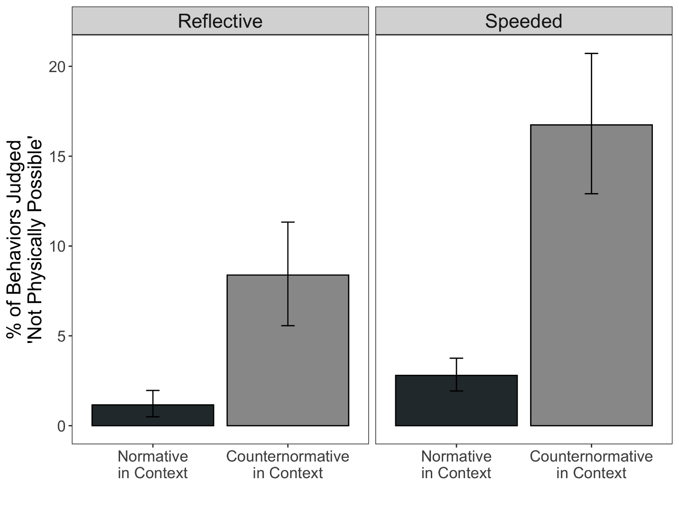
Note. Error bars represent bootstrapped 95% CIs (N=380).

Table S4. Mean percentage of behaviors judged “impossible” by condition in Study 2c, effects of speeded vs. reflective condition, and interaction between speeded condition and normativity. SDs indicated in parentheses (N=380).
 | Behaviors That Were Normative-In-Context | Behaviors That Were Counternormative-In-Context | Impossible Behaviors
Reflective | 0.98% (3.94) | 8.38% (20.96) | 96.17% (8.09)
Speeded | 2.49% (5.03) | 16.74% (26.64) | 89.41% (9.82)
Effect of time pressure (speeded vs. reflective) | Z=2.88, p=0.004 | Z=4.24, p<0.001 | Z=-7.56, p<0.001
Interaction with counternormative condition | χ²(1)=0.71, p=0.4 | - | χ²(1)=45.55, p<0.001

Study S4
Study 3 reported in the main text is a conceptual replication of Supplementary Study S4. The procedure is nearly identical except that Study S4 has fewer participants and only has the set of images displayed in Figure 3 of the main text, and not the counterbalanced version of the images that switch the location of the normatively afforded object (the cookies on the sale table) and the counternormative object (the cookies in the woman’s hands). As in Study 3, we hypothesized that people would be more likely to correctly identify the changed item (i.e., the box of cookies) when it was afforded by the social norms of the situation (i.e., was for sale) than when it was counternormative to act upon (i.e., was in the woman’s hands), but that this effect would only occur when the changed item was relevant to the participants’ goals.
Participants. Five-hundred and ninety-nine participants (M_{age}=39.80, SD=12.54; 46.1% female, 52.6% male, 1.2% non-binary or other; .2% American Indian /Native American, 6.8% Asian/Asian American, 5.3% Hispanic/Latinx, 9.5% Black/African-American, .2% Native Hawaiian/Other Pacific Islander, 73% White, 3.7% multiple races, .3% other) were recruited from Amazon Mechanical Turk using CloudResearch.
Materials and Procedure. Procedures were the same as those in Study 3 of the main text, except that, all participants only saw the set of images displayed in Figure 3 of the main text, and none saw the counterbalanced versions that switch the location of the normatively afforded object and the counternormative object.
Results. Participants in the goal-relevant condition reported being more focused on finding something to eat (M=4.45, SD=.87) than participants in the goal-irrelevant condition (M =1.31, SD=.76), t(597)=47.12, p<.001, d=3.62. Additionally, participants rated buying cookies from the sale table as much more appropriate (M=4.16, SD=.92) than taking cookies from the woman (M=1.31, SD=.85), paired samples t-test, t(598)=54.25, p<.001, d=2.22.
Using a binary logistic regression, we found a main effect of goal condition such that people were more likely to detect the change when that changed object was goal-relevant than when it was goal-irrelevant (b=1.14, se=.14, Wald χ²(1) = 67.67, p<.001). We did not observe a significant main effect of the normative affordance of changed object (b=.16, se=.14, Wald χ²(1) = 1.27, p=.26). As shown in Figure S4, these main effects were qualified by a significant interaction between goal-relevance and normative affordance of the changed object (b=.32, se=.14, Wald χ²(1) = 5.19, p=.02). Breaking down the simple effects of this interaction, we found that when the changed object was relevant to participants’ goals (i.e., participants were looking for food), participants were less likely to correctly identify the change when it occurred on the counternormative object than on the normatively afforded object (estimated probability of correctly identifying change 28.3% vs. 50.3%), b=-.47, se=.12, Wald χ²(1) = 15.19, p<.001. We did not find evidence for a simple effect of normative affordance on identifying the changed item for participants in the goal-irrelevant condition (estimated probability of correctly identifying change 7.1% vs. 5.2%), b=.16, se=.25, Wald χ²(1) = .41, p=.52.
Overall, across Study 3 and Supplemental Study S4, we found consistent support for our predicted pattern of results. Rates of detecting change were at near floor levels in the goal-irrelevant condition (3.2% to 7.1%). On the other hand, in the goal-relevant condition, rates of detecting change depended on the normativity of engaging with the object that changed—when the changed object was normative to engage with (i.e., was a box of cookies for sale) roughly half of participants in each sample detected the change (54.5% in Study 3 and 50.3% in Supplemental Study S4); when the changed object was counternormative to engage with, this figure was closer to one-quarter of participants (24.9% in Study 3 and 28.3% in Supplemental Study S4).

Figure S4. Estimated probability of correctly identifying which object changed. Plotted as a function of whether participants were primed with a goal that was relevant vs. irrelevant to the changed object and whether the changed object was normative to engage with vs. counternormative to engage with (Supplemental Study S4).

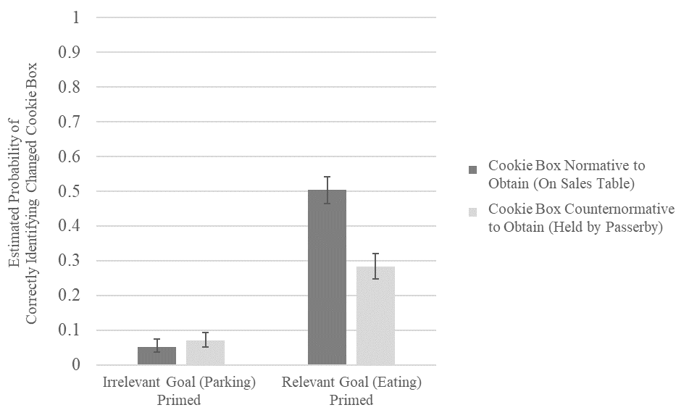
Note. Error bars represent standard errors.

Supplemental Figures for Study 4

Figure S5. Results for each scenario (Study 4).

Self-Control Conflict Composites for Each Scenario Pair
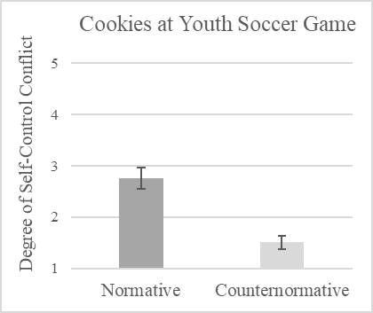
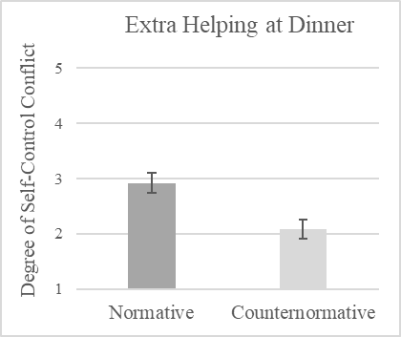
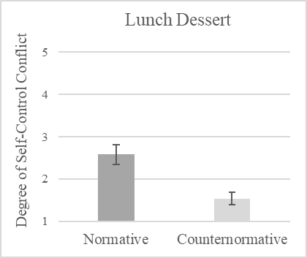
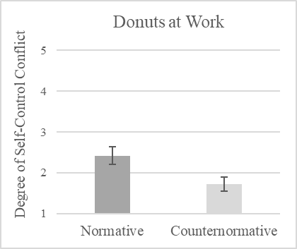

d = .70
d = 1.03
d = .91
d = 1.38

Note. Error bars represent 95% confidence intervals (N for each item=209).

Figure S6. Results for each scenario (Study 4).

How likely would you be to do each behavior?

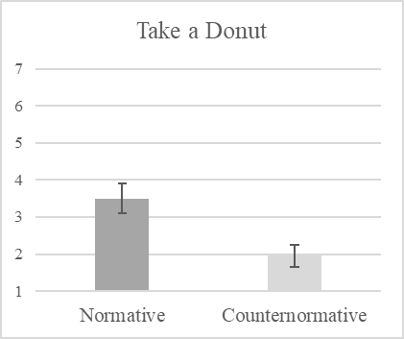
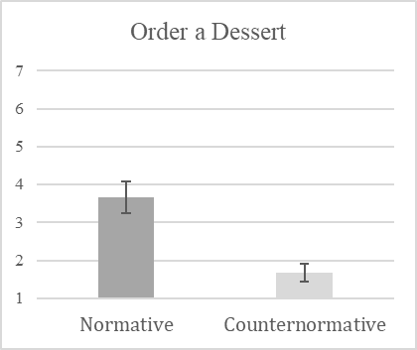
Very Likely

Very Unlikely

d = .82
d = 1.15

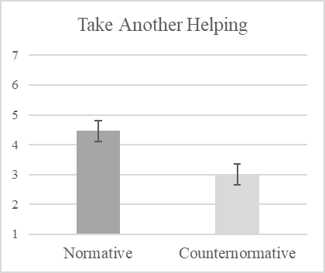
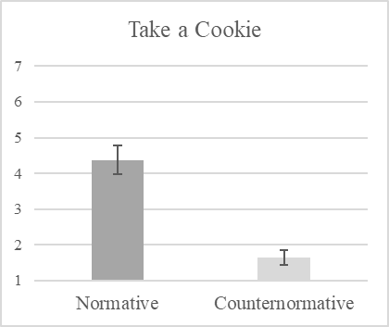
Very Likely

Very Unlikely
d = .79
d = 1.64

Note. Error bars represent 95% confidence intervals (N for each item=209).

Study S5: Plan-Writing Task
In Term 1 of Study 5 described in the main text, all students were encouraged to write a plan for their technology use in class. Half of students were further randomly assigned to receive additional information about multitasking and suggestions of strategies for modifying their situation in class to reduce the temptation to multitask. Below we report details of this manipulation.
Data for Studies S5 and S6 can be obtained by contacting the corresponding author.
Participants. A total of 257 students were initially enrolled, of whom 243 participated in the plan-writing task and consented to have their data analyzed.
Materials and procedure. In the first week of the semester, students attended a lecture on behavioral research methods, which discussed research showing that laptop use in class can interfere with learning and course performance. Later that week, all students were invited to write down a plan for technology use in class, and answered questions about their attitudes towards multitasking. This plan-writing task was delivered as an ungraded, optional section following an online quiz.
Half of students were randomly assigned to receive additional information focused on the costs of multitasking and strategies to reduce temptations to multitask. In the treatment group, students read about how multitasking can lead to “distraction pollution” that interferes with others’ learning, including a brief summary of a study finding that being able to view multitasking neighbors in class hurt students’ exam performance (Sana et al., 2013). Students were asked to indicate whether they had ever felt distracted by what someone else was doing in class (yes/no) and to indicate whether they thought students share a responsibility to create an environment where everyone can learn (almost all students agreed, 98.4%). Students then answered five questions about their motivation to avoid multitasking and beliefs about multitasking (e.g., “How important is it for you personally to avoid multitasking in class?”; 1=Not at all, 5=Extremely; “To what extent do you think that multitasking with technology in class impairs learning for the student who is multitasking?”; 1=Not at all, 5=A great deal). Finally, students read brief testimonials by past students describing how they used strategies to reduce the temptation to multitask. These included leaving their phone in their backpack, turning their phone to airplane mode, writing notes on paper instead of on a computer, and using software to block social media sites during class. Students were asked to write down their plan for using technology in class and concrete steps they planned to take.
In the control group, students answered the five questions about multitasking and were instructed to write down their plan for technology use in class and concrete steps they planned to take. However, they did not receive additional information about or reflect on “distraction pollution” or read student testimonials endorsing strategies to reduce multitasking temptations.
Follow-up surveys, delivered at Time 1 and 2, assessed students’ multitasking behavior and temptation, as described in the main text. At Time 1 students also reported on the proportion of lectures in which they had used various situational strategies for avoiding multitasking on laptops (turning wifi off, putting away laptops, or using apps to block distracting websites) and on phones (turning on airplane mode or keeping their phone in their backpack).
Results. There were significant differences between the treatment and control groups on mention of situation-modification strategies in students’ written plans immediately after the treatment and attitudes towards multitasking. However, there was no difference in longer-term behavior change or reports of temptation. Details follow.
First, students’ plans were coded for the presence of situation-modification strategies related to phone or laptop use (e.g., turning phone on airplane mode, putting away a computer and writing notes on paper) by a trained coder blind to condition. A second coder, also blind to condition, coded a subset of the same plans (N=100). Interrater reliability was high (κ=.88, p<0.001). Compared to control-condition students, students in the treatment group were more likely to mention situation-modification strategies for both laptops (78% vs. 48%, χ2(1)=20.40, p<0.001) and phones (68% vs. 13%, χ2(1)=70.17, p<0.001).
The questions assessing attitudes towards multitasking in class exhibited acceptable reliability (Cronbach’s α=0.76) and were averaged to create a single measure. Students viewed multitasking as harming learning and as to be avoided more so in the treatment condition (M=3.77, SD=0.57) than in the control condition (M=3.60, SD=0.73, t(226.18)=2.07, p=0.039, d=0.27).
However, this initial change did not translate into greater use of situational strategies. At Time 1, four weeks after the plan-writing task, students in the intervention condition were no more likely to have report having used situational strategies for laptops (intervention=50.88%, control=58.78%, χ2(1)=1.29, p=0.257) or phones (intervention=80.7%, control=82.45%, χ²(1)=0.03, p=0.864). Among students who reported using situational strategies at least some of the time, there were also no significant differences in the proportion of lectures in which they were used (laptops: M_{treat}=44.12, SD_{treat}=48.33, M_{control}=44.56, SD_{control}=48.74, t(225.98)=0.13, p=0.946; phones: M_{treat}=73.6, SD_{treat}=59.85, M_{control}=80.96, SD_{control}=62.3, t(225.64)=0.91, p=0.364).
Similarly, there was no reduction in the number of minutes students reported spending multitasking on their laptops and phones (Median_{treat}=8, IQR_{treat}=(4, 15), Median_{control}=10, IQR_{control}=(3, 20)), U=6788.5, p=0.345, or in self-reported temptation to multitask in class (M_{treat}=2.77, SD_{treat}=1.03, M_{control}=2.60, SD_{control}=1.14), t(219.54)=1.24, p=0.247. The same measures, taken 10 weeks after the intervention, again showed no differences (all ps>0.5).
Providing students strategies for situation modification and testimonials from peers about using these strategies and encouraging them to consider how multitasking could distract others was not inert. It led students to view multitasking as harmful to learning and to be avoided as well as to develop plans for regulating their own technology use in class. However, these differences did not persist to affect later strategy use or to reduce multitasking behavior or students’ experiences of temptation.
For purposes of comparison to the “no tech norm” term in Study 5, it is worth noting that overall students in the “tech-allowed” term expressed strong motivation to avoid multitasking in class. Most students reported that they found it “very” or “extremely” important for them personally to avoid multitasking in class (75%, M=4.09, SD=0.94), and the majority reported being “very” or “extremely” motivated to do so (65%; M=3.73, SD=0.98).

Study 5 Additional Details
Imputation of missing values. The questions assessing minutes spent multitasking on laptops and phones had a disproportionate number of missing values: 25% of values were missing for these questions, compared to 1% of values for the “times multitasking” question that immediately followed on the same page. We believe this disparity reflects a quirk in how the question was displayed: whereas the “times multitasking” question was an empty text box, the “minutes multitasking” questions were presented as a slider that by default seems to have been set to zero. We suspect that many students who did not click to change the slider’s value did so because they intended to answer what appeared to be the default value (0). Yet the survey software recorded such nonclicks as missing values. We thus recoded missing values for these questions according to the following algorithm: We examined only the subset of students who answered the “times multitasking” question, which appeared on the same survey page. If a student answered that they had multitasked zero times, we imputed zeroes for the “minutes - phone” and “minutes - laptop” questions. If a student indicated that they had multitasked more than once, but left both “minutes - phone” and “minutes - laptop” blank, the answers were left coded as missing. Finally, if the student answered the “times multitasking” question and one of the “minutes” questions, but left the other “minutes” value unclicked, we imputed a zero for that value. These imputed values are used in analyses reported in the main text.
To ensure that the results were not driven by this imputation process, we confirmed that differences between terms remained significant using the non-corrected data: students spent fewer minutes multitasking on laptops and phones in the no-tech term at both Time 1 (Median_{no-tech}=5, Median_{laptops-allowed}=10, U=23471, p=0.003), and Time 2 (Median_{no-tech}=5, Median_{laptops-allowed}=11, U=31044, p<0.001).

Table S5. Demographic characteristics of students in Study 5.
 | Term 1 (Strategy intervention; Laptops Allowed) | Term 2 (No-tech norm)
N | 246 | 248
Gender | 55% female | 50% female
Race/ethnicity | 56% White, 22% Asian, 12% Black, 5% Hispanic/Latinx, 5% multiple racial-ethnic identities, <1% Native American | 53% White, 28% Asian, 6% Black, 4% Hispanic/Latinx, 7% multiple racial-ethnic identities, <1% Pacific Islander, <1% Native American

Study S6
Study S6 compared two terms of an introductory psychology course at a different selective, private university. In one term, students were permitted to use laptops in class; in a second term, instructors established a no-technology norm as in Study 5. As noted in the main text, Study S6 tests the same question as Study 5 and finds similar results.
Term comparison. Study S6 is presented in the supplement because, although important features of the course were matched across the two terms, including the course content, materials and pedagogy, and university, the two terms were taught by different instructors and occurred in different times of the year (Fall vs. Winter), leading to different class sizes. In the tech-allowed (Fall) term, 252 students were enrolled in the course, of whom 247 participated in the plan-writing task and 221 completed the end-of-term survey. In the no-tech (Winter) term, 145 students were enrolled in the course, of whom 143 completed the end-of-term survey.
Materials and procedure. In the first week of class, students in both terms attended a lecture on behavioral research methods that described how multitasking on a laptop during class can interfere with learning, and correlational and experimental research supporting this conclusion.
In the tech-allowed term, students then participated in a self-regulation intervention, delivered as an ungraded section following an online quiz released two days after the lecture on multitasking. Students were randomly assigned to read one of two versions of a situation-modification intervention. In all cases, messages included suggestions for situation-modification strategies related to technology use—leaving one’s phone in one’s bag or using airplane mode, writing notes on paper instead of on a computer, turning off wifi, not using a laptop in class, or using software to block distracting websites—and an invitation to write a concrete plan for managing technology use in class (“e.g., when I get to class, I’ll put my phone on airplane mode”). One variant of the intervention focused on peers, conveying survey results from past terms in which a majority of students reported feeling bothered by other students’ multitasking and using situation-modification strategies to avoid multitasking in class. The second variant did not include this information and instead focused on the link between multitasking and grades.
After writing their plan for technology use in class, students rated their motivation to follow through with the plan (1=not motivated at all, 7=extremely motivated), and were invited to comment on what they might do in the future to stay motivated to stick to the plan. Although students who read the peer message reported higher initial motivation to stick with their plans, t(218.08)=3.11, p=0.002, d=0.40, no significant differences in later temptation or behavior were observed. Thus, the two versions of the strategy intervention are not discussed further.
In both terms, an end-of-term survey assessed students’ multitasking in class. To encourage honest reporting, students were told that their responses would be viewed with their names removed. Students reported on what devices they brought to class, the percentage of class time they had spent multitasking on electronic devices (0-100 slider), how often they engaged in eight multitasking activities during class time (emailing, texting, doing coursework for other classes, online shopping, playing a game, watching a video, checking social media, and reading the news; 1=Never, 5=Every lecture), how tempted they felt to engage in each activity (1=Not at all, 5=Very), and how inappropriate or appropriate they thought it was to engage in each activity during lecture (1=extremely inappropriate, 7=extremely appropriate). Students also indicated how beneficial they thought a no-technology policy would be for future students in the class (1=Not beneficial at all, 5=Extremely beneficial).
Students in the no-tech norm classroom were additionally asked “During an average lecture, how many times does the thought of using your [phone/laptop] pop into your mind?” (text entry), and whether they would support making a no-tech policy the default in lecture classes (1=Strongly oppose, 7=Strongly support).
Results. Students in the tech-allowed (control) classroom reported high motivation to stick to their situation-modification plans (M=5.94 on a 1-7 scale; SD=1.09). Further, students in both terms viewed the eight multitasking activities (e.g., email, texting, shopping) as equally inappropriate to engage in during class time (averaging across activities, M_{control}=2.18, SD_{control}=1.13, M_{no-tech}=2.11, SD_{no-tech}=1.17, t(289.49)=0.55, p=0.584).
Replicating Study 5, at the end of the term students in the no-tech norm classroom reported spending a smaller percentage of class time multitasking overall (Median_{control}=11, IQR_{control}=[5,26], Median_{no-tech}=5, IQR_{no-tech}=[1,15]) U=17203, p<0.001. They also reported multitasking during class time less often (M_{control}=1.80, SD_{control}=0.64, M_{no-tech}=1.67, SD_{no-tech}=0.51), t(335.56)=2.20, p=0.028, d=0.22.
Further, students in the no-tech norm classroom also experienced less temptation to engage in multitasking (M_{control}=2.08, SD_{control}=0.87, M_{no-tech}=1.86, SD_{no-tech}=0.65), t(330.85)=2.86, p=0.004, d=0.29. Strikingly, most students in the no-tech norm classroom (80%) said the thought of using their laptops popped into their heads zero times during an average lecture, even though equal proportions of students brought their laptops to class in the no-tech norm term (56%) and the tech-allowed term (58%).
As in Study 5, there were also strong shifts in students’ evaluation of the no-tech norm. Students in the tech-allowed term wrote that a no-tech classroom would be “a bit authoritarian,” “a huge turn-off,” “overly restrictive and authoritative,” that they would “hate it,” that “students should be able to regulate themselves,” that “it should be up to the students themselves to motivate and avoid distraction,” and that “any sort of prohibitory rule would be absolutely restrictive and not beneficial to learning at all.” Yet, evaluations were markedly positive among students who experienced the no-tech norm. Whereas only 24% of students in the tech-allowed term thought that the policy would be “very” or “extremely” beneficial, this proportion rose to 80% in the no-tech norm classroom (M_{control}=2.55, SD_{control}=1.32, M_{no-tech}=4.17, SD_{no-tech}=0.96), t(355)=13.56, p<0.001, d=1.40. Students wrote that the no-tech norm “made it so much easier to focus. In other lectures when anyone sits in front of me with a laptop, I tend to have wandering eyes…rather than paying attention,” that “having no technology made me more engaged in lecture compared to my other classes that did allow technology,” that “the most helpful part was not seeing other people multitask,” and that “no technology is the way to go.” A further 81% of students in the no-tech norm term supported making this policy the default for lecture classes at their institution (this question was not assessed in the tech-allowed term).
Discussion. As in Study 5, changing norms by implementing a no-tech policy had a far greater effect on students’ temptations to multitask and multitasking behavior than introducing self-regulatory strategies and asking students to make a plan for self-regulated technology use. This difference is especially notable given that students in the tech-allowed classroom reported high motivation to stick to their plans for avoiding multitasking. Moreover, students who experienced the no-tech norm again found it beneficial and endorsed its use in future courses.

Table S6. Demographic characteristics of students in Supplemental Study S5.
 | Term 1 (Strategy intervention) | Term 2 (No-tech norm)
N | 221 | 143
Gender | 62% female | 59% female
Race/ethnicity | 38% White, 23% Asian/Pacific Islander, 6% Black, 10% Hispanic/Latinx, <1% Native American,  23% other/multiple racial-ethnic identities | 43% White, 27% Asian/Pacific Islander, 6% Black, 6% Hispanic/Latinx, 1% Native American,  17% other/multiple racial-ethnic identities

